Week 1
Clarification about Upcoming Regularization Video
Please note that in the next video at 5:45, the Frobenius norm formula should be the following:
$∣∣w^{\left[l\right]}∣∣^{2}=\sum_{i=1}^{n^{\left[l\right]}}{\sum_{j=1}^{n^{\left[l − 1\right]}}{(}}w_{i,j}^{\left[l\right]})^{2}$
- The limit of summation of i should be from 1 to $n^{\left[l\right]}$
- The limit of summation of j should be from 1 to $n^{\left[l − 1\right]}$
- (it's flipped in the video). The rows "i" of the matrix should be the number of neurons in the current layer $n^{\left[l\right]}$.
- whereas the columns "j" of the weight matrix should equal the number of neurons in the previous layer $n^{\left[l − 1\right]}$
Clarification about Upcoming Understanding Dropout Video
- Please note that in the next video from around 2:40 - 2:50, the dimension of $w^{\left[1\right]}$ should be 7x3 instead of 3x7, and $w^{\left[3\right]}$ should be 3x7 instead of 7x3.
- In general, the number of neurons in the previous layer gives us the number of columns of the weight matrix, and the number of neurons in the current layer gives us the number of rows in the weight matrix.

Week 1 QUIZ
Question 1
If you have 10,000,000 examples, how would you split the train/dev/test set?
98% train . 1% dev . 1% test
Question 2
In a personal experiment, an M.L. student decides to not use a test set, only train-dev sets. In this case which of the following is true?
He might be overfitting to the dev set.
Yes. Although not recommended, if a more accurate measure of the performance is not necessary it is ok to not use a test set. However, this might cause an overfit to the dev set.

Question 3
If your Neural Network model seems to have high variance, what of the following would be promising things to try?
Add regularization
Get more training data
Question 4
Your classifier for bananas and oranges gets a training set error of 0.1% and a development set error of 11%.
Which of the following statements are true? (Check all that apply.)
The model has a very high bias.
The model has a high variance.
Nice work
The large gap between training and development set errors is a hallmark of high variance.
The model is overfitting the development set.
This should not be selected
Overfitting the development set would result in a very low error on it.
The model is overfitting the training set.
0.5 / 1 point
Question 5
In every case it is a good practice to use dropout when training a deep neural network because it can help to prevent overfitting. True/False?
False
Question 6
True or False: To reduce high variance, the regularization hyperparameter lambda must be increased.
True
Nice work
Correct. By increasing the regularization parameter the magnitude of the weight parameters is reduced. This helps reduce the variance.
Question 7
Which of the following are true about dropout?
It helps to reduce overfitting.
Nice work
Correct. The dropout is a regularization technique and thus helps to reduce the overfit.
In practice, it eliminates units of each layer with a probability of 1- keep_prob.
Nice work
Correct. The probability that dropout doesn't eliminate a neuron is keep_prob.
Question 8
Decreasing the parameter keep_prob from (say) 0.6 to 0.4 will likely cause the following:
Increasing the regularization effect.
Nice work
Correct. This will make the dropout have a higher probability of eliminating a node in the neural network, increasing the regularization effect.
Question 9
Which of the following actions increase the regularization of a model? (Check all that apply)
Use Xavier initialization.
This should not be selected
Incorrect. Xavier doesn't have any effect on reducing the variance of the model, thus it's not a regularization technique.
Decrease the value of the hyperparameter lambda.
Increase the value of the hyperparameter lambda.
Nice work
Correct. When increasing the hyperparameter lambda, we increase the effect of the L_2 penalization.
Decrease the value of keep_prob in dropout.
Nice work
Correct. When decreasing the keep_prob value, the probability that a node gets discarded during training is higher, thus reducing the regularization effect.
Increase the value of keep_prob in dropout.
0.8 / 1 point

Question 10
Why do we normalize the inputs $x$?
It makes the cost function faster to optimize
Nice work

Week 2
Reflect from the Mini-batch Gradient Descent.
L has been used previously to indicate the number of the layer in the network, in this particular example was also used to indicate the number of samples in the mini-batch.

Clarification about Upcoming Adam Optimization Video
Please note that in the next video at 2:44, the following picture is correct. However, later in the video, the $db^{2}$ lost the ${}^{2}$.
The bottom right equation should be:
$$S_{db}=β_{2}S_{db}+(1-β_{2})db^{2}$$

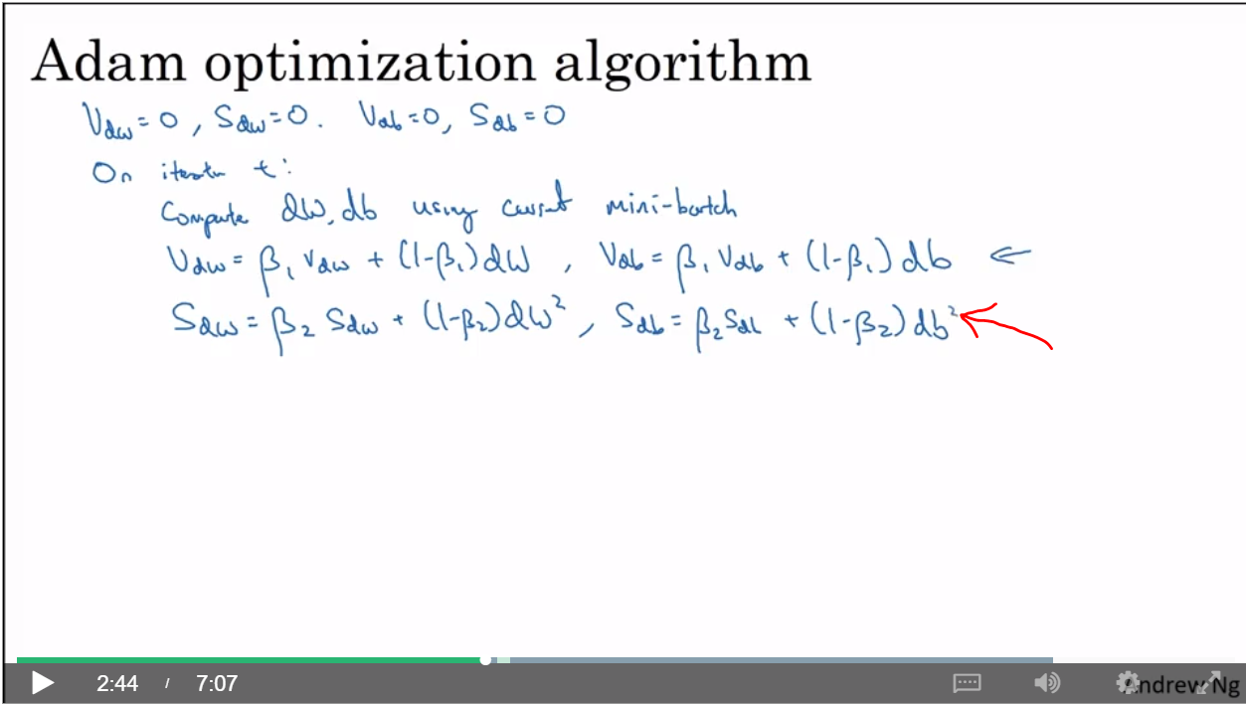

Clarification about Learning Rate Decay Video
Please note that in the next video, the formula for learning rate decay $α$ is:
$$α=\frac{1}{1+decayRate×epochNumber}α_{0}$$

Reflect
Please note, the values Andrew writes for Epoch 2, Epoch 3 and Epoch 4 are incorrect.
Andrew will write:
Epoch | $$α$$
1 | 0.1
2 | 0.67
3 | 0.5
4 | 0.4

But these values will be later corrected at 3:31 onwards. Please note these values instead:
Epoch | $$α$$
1 | 0.1
2 | 0.067
3 | 0.05
4 | 0.04

WEEK 2 Quiz
Question 1
Which notation would you use to denote the 4th layer’s activations when the input is the 7th example from the 3rd mini-batch?
$$a^{[4]\{3\}(7)}$$
Nice work
Yes. In general $a^{[l]\{t\}(k)}$ denotes the activation of the layer $l$ when the input is the example $k$ from the mini-batch $t$.
1 / 1 point

Question 2
Which of these statements about mini-batch gradient descent do you agree with?
When the mini-batch size is the same as the training size, mini-batch gradient descent is equivalent to batch gradient descent.
Nice work
Correct. Batch gradient descent uses all the examples at each iteration, this is equivalent to having only one mini-batch of the size of the complete training set in mini-batch gradient descent.
1 / 1 point

Question 3
Why is the best mini-batch size usually not 1 and not m, but instead something in-between? Check all that are true.
If the mini-batch size is 1, you lose the benefits of vectorization across examples in the mini-batch.
Nice work
If the mini-batch size is m, you end up with batch gradient descent, which has to process the whole training set before making progress.
Nice work
1 / 1 point

Question 4
While using mini-batch gradient descent with a batch size larger than 1 but less than m the plot of the cost function $J$ looks like this:
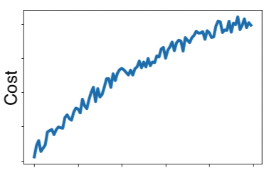
Which of the following do you agree with?
- If you are using mini-batch gradient descent or batch gradient descent this looks acceptable.
- No matter if using mini-batch gradient descent or batch gradient descent something is wrong.
- If you are using mini-batch gradient descent, this looks acceptable. But if you're using batch gradient descent, something is wrong.
- If you are using batch gradient descent, this looks acceptable. But if you're using mini-batch gradient descent, something is wrong.
Try again
No. The cost is larger than when the process started, this is not right at all.
0 / 1 point

Question 5
Suppose the temperature in Casablanca over the first two days of January are the same:
Jan 1st: $θ_{1}=10^{o}C$
Jan 2nd: $θ_{2}=10^{o}C$
(We used Fahrenheit in the lecture, so we will use Celsius here in honor of the metric world.)
Say you use an exponentially weighted average with $β=0.5$to track the temperature: $v_{0}=0$, $v_{t}=βv_{t-1}+(1-β)θ_{t}$ is the value you compute with bias correction. What are these values? (You might be able to do this without a calculator, but you don't actually need one. Remember what bias correction is doing.)
$v_{2}=7.5$, $v_{2}^{corrected}=10$
Nice work
1 / 1 point

Question 6
Which of these is NOT a good learning rate decay scheme? Here, $t$t is the epoch number.
$$α=1.01^{t} α_{0}$$
Nice work
Correct. This is not a good learning rate decay since it is an increasing function of $t$.
1 / 1 point

Question 7
You use an exponentially weighted average on the London temperature dataset. You use the following to track the temperature: $v_{t}=βv_{t-1}+(1-β)θ_{t}$. The red line below was computed using $β=0.9$. What would happen to your red curve as you vary $β$? (Check the two that apply)
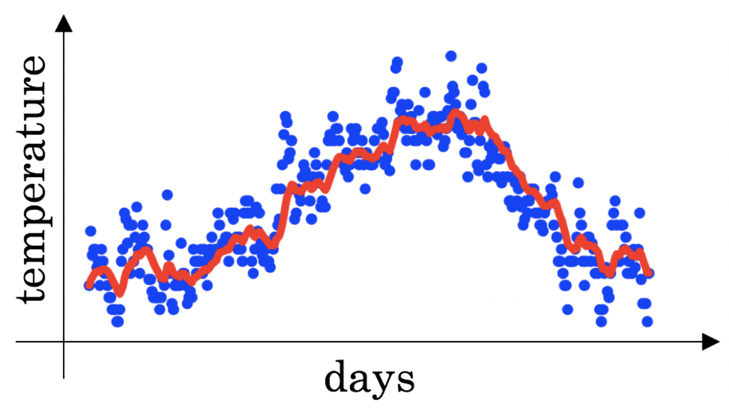
Increasing $β$ will shift the red line slightly to the right.
Nice work
True, remember that the red line corresponds to $β=0.9$. In the lecture we had a green line $β=0.98$ that is slightly shifted to the right.
Decreasing $β$ will create more oscillation within the red line.
Nice work
True, remember that the red line corresponds to $β=0.9$. In lecture we had a yellow line $β=0.98$ that had a lot of oscillations.
1 / 1 point

Question 8
Consider the figure:
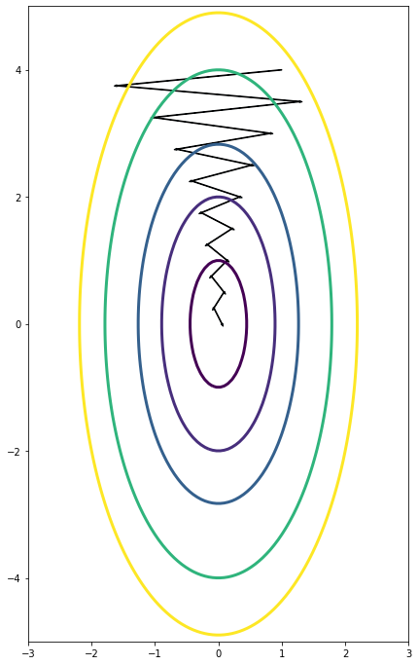
Suppose this plot was generated with gradient descent with momentum $β=0.01$. What happens if we increase the value of $β$ to $0.1$?
The gradient descent process moves less in the horizontal direction and more in the vertical direction.
Nice work
Yes. The use of a greater value of $β$beta causes a more efficient process thus reducing the oscillation in the horizontal direction and moving the steps more in the vertical direction.
1 / 1 point

Question 9
Suppose batch gradient descent in a deep network is taking excessively long to find a value of the parameters that achieves a small value for the cost function $J(W^{\left[1\right]},b^{\left[1\right]},...,W^{\left[L\right]},b^{\left[L\right]})$. Which of the following techniques could help find parameter values that attain a small value for $J$? (Check all that apply)
Try using Adam.
Nice work
Yes. Adam combines the advantages of other methods to accelerate the convergence of the gradient descent.
Try mini-batch gradient descent.
Nice work
Yes. Mini-batch gradient descent is faster than batch gradient descent.
Normalize the input data.
Nice work
Yes. In some cases, if the scale of the features is very different, normalizing the input data will speed up the training process.
1 / 1 point

Question 10
Which of the following statements about Adam is False?
We usually use “default” values for the hyperparameters $β_{1},β_{2}$ in Adam ($β_{1}=0.9$, $β_{2}=0.999$, $ε=10^{-8}$)
Adam should be used with batch gradient computations, not with mini-batches.
Nice work

WEEK 3
Clarification about Upcoming Normalizing Activations in a Network Video
Please note, as pointed out earlier in Week 1, the normalization should be: $X=X/σ$.
Clarifications about Upcoming Softmax Video
Please note that in the next video at 4:30, the text for the softmax formulas mixes subscripts "j" and "i", when the subscript should just be the same (just "i") throughout the formula.
So the formula for softmax should be:
$$a^{\left[L\right]}=\frac{e^{Z^{\left[L\right]}}}{\sum_{i=1}^{4}{t_{i}}}$$

(Optional) Learn about Gradient Tape and More:
To learn more about Gradient Tape, you can take Course 2: Custom and Distributed Training with TensorFlow of our TensorFlow: Advanced Techniques Specialization.

WEEK 3 QUIZ
Question 1
Which of the following are true about hyperparameter search?
- Choosing values in a grid for the hyperparameters is better when the number of hyperparameters to tune is high since it provides a more ordered way to search.
- Choosing random values for the hyperparameters is convenient since we might not know in advance which hyperparameters are more important for the problem at hand.
- When using random values for the hyperparameters they must be always uniformly distributed.
- When sampling from a grid, the number of values for each hyperparameter is larger than when using random values.
Try again
Incorrect. Since some problems are highly sensitive to the values of some hyperparameters it is best to use a logarithmic or exponential scale.
0 / 1 point

Question 2
If it is only possible to tune two parameters from the following due to limited computational resources. Which two would you choose?
$$α$$
Nice work
Correct. This might be the hyperparameter that most impacts the results of a model.
The $β$ parameter of the momentum in gradient descent.
Nice work
Correct. This hyperparameter can increase the speed of convergence of the training, thus is worth tuning.
1 / 1 point

Question 3
Even if enough computational power is available for hyperparameter tuning, it is always better to babysit one model ("Panda" strategy), since this will result in a more custom model. True/False?
False

Nice work
Correct. Although it is possible to create good models using the "Panda" strategy, obtaining better results is more likely using a "caviar" strategy due to the number of tests and the nature of the deep learning process of ideas, code, and experiment.
1 / 1 point

Question 4
Knowing that the hyperparameter $α$ should be in the range of $0.001$and $1.0$. Which of the following is the recommended way to sample a value for $α$?
r = -3*np.random.rand()
alpha = 10**r
Nice work
Yes. This gives a random number between $0.001=10^{-3}$ and $10^{0}$
1 / 1 point

Question 5
Once good values of hyperparameters have been found, those values should be changed if new data is added or a change in computational power occurs. True/False?
True

Nice work
Correct. The choice of some hyperparameters such as the batch size depends on conditions such as hardware and quantity of data.
1 / 1 point

Question 6
In batch normalization as presented in the videos, if you apply it on the $l$lth layer of your neural network, what are you normalizing?
$$z^{\left[l\right]}$$
Nice work
1 / 1 point

Question 7
When using normalization:
$$z_{norm}^{\left(i\right)}=\frac{z^{\left(i\right)}-μ}{\sqrt{σ^{2}+ε}}$$
In case $σ$ is too small, the normalization of $z^{\left(i\right)}$ may fail since division by 0 may be produced due to rounding errors. True/False?
False
Nice work
Correct. The normalization formula uses a smoothing parameter $ϵ$\epsilon so in $z_{\text{norm}}^{\left(i\right)}=\frac{z^{\left(i\right)}-μ}{\sqrt{σ^{2}+ϵ}}$ parameter prevents that the denominator be 0.
1 / 1 point

Question 8
Which of the following are true about batch normalization?
When using batch normalization we introduce two new parameters $γ^{\left[l\right]}$, $β^{\left[l\right]}$ that must be "learned" or trained.
Nice work
Correct. Batch normalization uses two parameters $β$ and $γ$ to compute ${\tilde{z}}^{\left(i\right)}=βz_{norm}^{\left(i\right)}+γ$
The parameters $γ^{\left[l\right]}$ and $β^{\left[l\right]}$ set the variance and mean of ${\tilde{z}}^{\left[l\right]}$
Nice work
Correct. When applying the linear transformation ${\tilde{z}}^{\left(l\right)}=β^{\left[l\right]}z_{norm}^{\left(l\right)}+γ^{\left[l\right]}$ we set the variance and mean of ${\tilde{z}}^{\left[l\right]}$
1 / 1 point

Question 9
A neural network is trained with Batch Norm. At test time, to evaluate the neural network on a new example you should perform the normalization using $μ$ and $σ^{2}$, squared estimated using an exponentially weighted average across mini-batches seen during training. True/false?
True
Nice work
Correct. This is a good practice to estimate the $μ$ and $σ^{2}$, squared to use since at test time we might not be predicting over a batch of the same size, or it might even be a single example, thus using the $μ$ and $σ^{2}$, squared of a single sample doesn't make sense.
1 / 1 point

Question 10
Which of these statements about deep learning programming frameworks are true? (Check all that apply)
Even if a project is currently open source, good governance of the project helps ensure that it remains open even in the long term, rather than become closed or modified to benefit only one company.
Nice work
A programming framework allows you to code up deep learning algorithms with typically fewer lines of code than a lower-level language such as Python.
Nice work

REFERENCES:
Week 3:
- Introduction to gradients and automatic differentiation (TensorFlow Documentation)
- tf.GradientTape (TensorFlow Documentation)

